**Exercise 8 – Angular JS Navigation Menu**

**Name:** Badri MSV **Roll No:** 195002017

**Subject:** UIT1611 – Web Programming Lab **Faculty:** Dr. S. Sasirekha

**Date:**

**Aim:**

Design a Navigation Menu for the website using angular JS.

**Algorithm:**

* Include Angular JS and Angular route links using script tag.
* Define the separate pages under type=”text/ng-template” using script
* Use ng-route to route to the respective pages based on the value of $routeprovider.
* Defining separate controllers for each application.
* In this application, users can navigate to the respective webpage using the navigation menu at the top. Calculator and To Do List are provided as samples to navigate.

**Code:**

**index.html**

<!DOCTYPE html>

<html lang="en" ng-app='myApp'>

<head>

    <title>Exercise 8</title>

    <link rel="stylesheet" href="https://cdn.jsdelivr.net/npm/bootstrap@4.0.0/dist/css/bootstrap.min.css" integrity="sha384-Gn5384xqQ1aoWXA+058RXPxPg6fy4IWvTNh0E263XmFcJlSAwiGgFAW/dAiS6JXm" crossorigin="anonymous">

    <script src="https://code.angularjs.org/1.7.3/angular.min.js"></script>

    <script src="https://code.angularjs.org/1.7.3/angular-route.min.js"></script>

    <script src="https://code.jquery.com/jquery-3.2.1.slim.min.js" integrity="sha384-KJ3o2DKtIkvYIK3UENzmM7KCkRr/rE9/Qpg6aAZGJwFDMVNA/GpGFF93hXpG5KkN" crossorigin="anonymous"></script>

    <script src="https://cdn.jsdelivr.net/npm/popper.js@1.12.9/dist/umd/popper.min.js" integrity="sha384-ApNbgh9B+Y1QKtv3Rn7W3mgPxhU9K/ScQsAP7hUibX39j7fakFPskvXusvfa0b4Q" crossorigin="anonymous"></script>

    <script src="https://cdn.jsdelivr.net/npm/bootstrap@4.0.0/dist/js/bootstrap.min.js" integrity="sha384-JZR6Spejh4U02d8jOt6vLEHfe/JQGiRRSQQxSfFWpi1MquVdAyjUar5+76PVCmYl" crossorigin="anonymous"></script>

    <script src="main.js"></script>

</head>

<body style="background-color: aliceblue;">

    <nav class="navbar navbar-expand-lg navbar-dark bg-dark">

      <a class="navbar-brand" href="#">Exercise 8</a>

      <button class="navbar-toggler" type="button" data-toggle="collapse" data-target="#navbarNavAltMarkup" aria-controls="navbarNavAltMarkup" aria-expanded="false" aria-label="Toggle navigation">

        <span class="navbar-toggler-icon"></span>

      </button>

      <div class="collapse navbar-collapse" id="navbarNavAltMarkup">

        <div class="navbar-nav">

          <a class="nav-item nav-link" href="#!">Home <span class="sr-only">(current)</span></a>

          <a class="nav-item nav-link" href="#!/calculator">Calculator</a>

          <a class="nav-item nav-link" href="#!/todo">ToDo</a>

        </div>

      </div>

    </nav>

    <div ng-view>

    </div>

</body>

</html>

**home.html**

<h1 style="text-align:center;">This is the homepage!</h1>

**todo.html**

<div ng-controller="mainController" style="padding-left:10px;">

    <h1 style="text-align:center;"><u>ToDo list</u></h1>

    <br>

    <p>Name: <input type="text" ng-model="name"></p>

    <br>

    <h4>Welcome <b>{{name}}</b></h4>

    <hr>

    <br>

    <div style="border: 1px solid black; padding:10px 10px 10px 10px;">

        <p>Enter task here: <input type="text" ng-model="task"> <input type="submit" value="Add Task" ng-click="addTask(task)"></p>

        <p>Tasks Pending!</p>

        <ol>

            <li ng-repeat="task in task_list">{{task}}</li>

        </ol>

    </div>

    <br>

    <div style="border: 1px solid black; padding:10px 10px 10px 10px;">

        <p>Enter task number completed: <input type="number" ng-model="del_task"> <input type="submit" value="Completed Task" ng-click="deltask(del_task)"></p>

        <p>Tasks Completed!</p>

        <ol>

            <li ng-repeat="task in completed_task_list">{{task}}</li>

        </ol>

    </div>

</div>

**calculator.html**

<h1 style="text-align:center;"> Calculator</h1>

<div style="padding: 10px 10px 10px 10px;">

<h3>First Number: <input type="number" ng-model="number1"></h3>

<h3>Second Number: <input type="number" ng-model="number2"></h3>

        <div style="border: 1px solid black;">

            <h4>Sum : {{ number1 + number2 }}</h4>

            <h4>Difference : {{ number1 - number2}}</h4>

            <h4>Multiply : {{ number1 * number2}}</h4>

            <h4>Divide : {{ number1 / number2}}</h4>

        </div>

<hr>

</div>

**main.js**

var myApp = angular.module('myApp' , ['ngRoute']);

myApp.config(function($routeProvider){

    $routeProvider

    .when("/" , {

        templateUrl: "pages/home.html"

    })

    .when("/calculator" , {

        templateUrl: "pages/calculator.html"

    })

    .when("/todo" , {

        templateUrl: "pages/todo.html",

        controller: 'mainController'

    })

})

myApp.controller('mainController', function($scope){

    $scope.name="";

    $scope.task_list=[];

    $scope.completed_task_list=[];

    console.log($scope.task_list);

    $scope.addTask = function(task){

        $scope.task = "";

        $scope.task_list.push(task);

    }

    $scope.delTask = function(index){

        $scope.del_task="";

        $scope.completed_task_list.push($scope.task_list[index]);

        $scope.task_list.splice(index-1,1);

    }

});

**Output:**

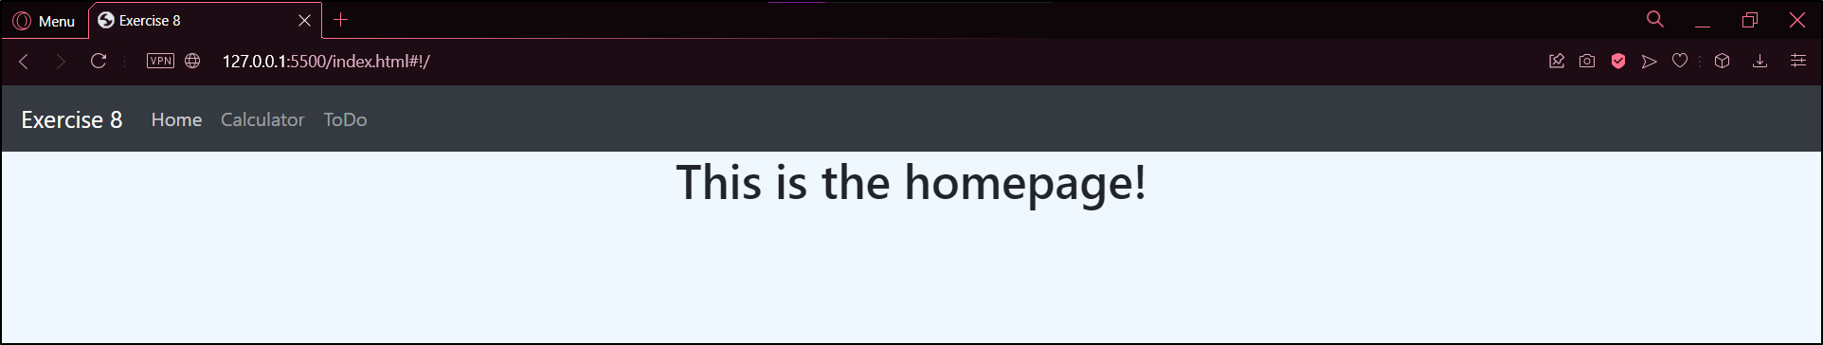

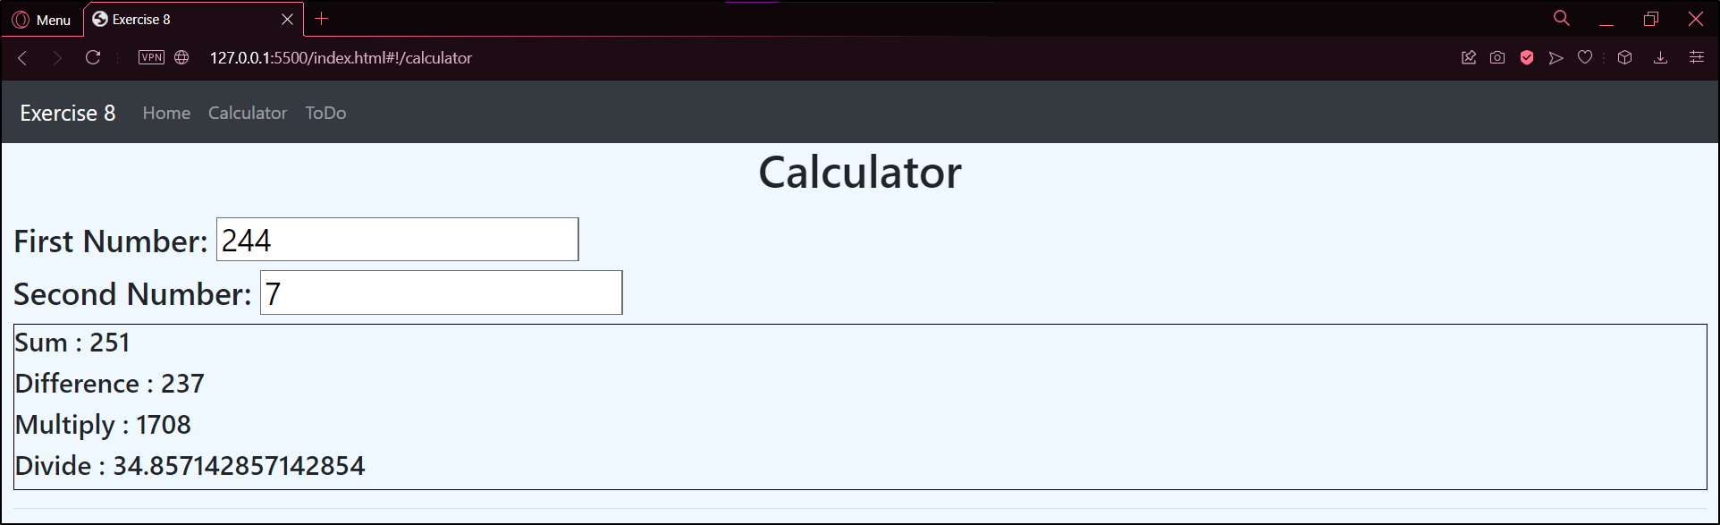

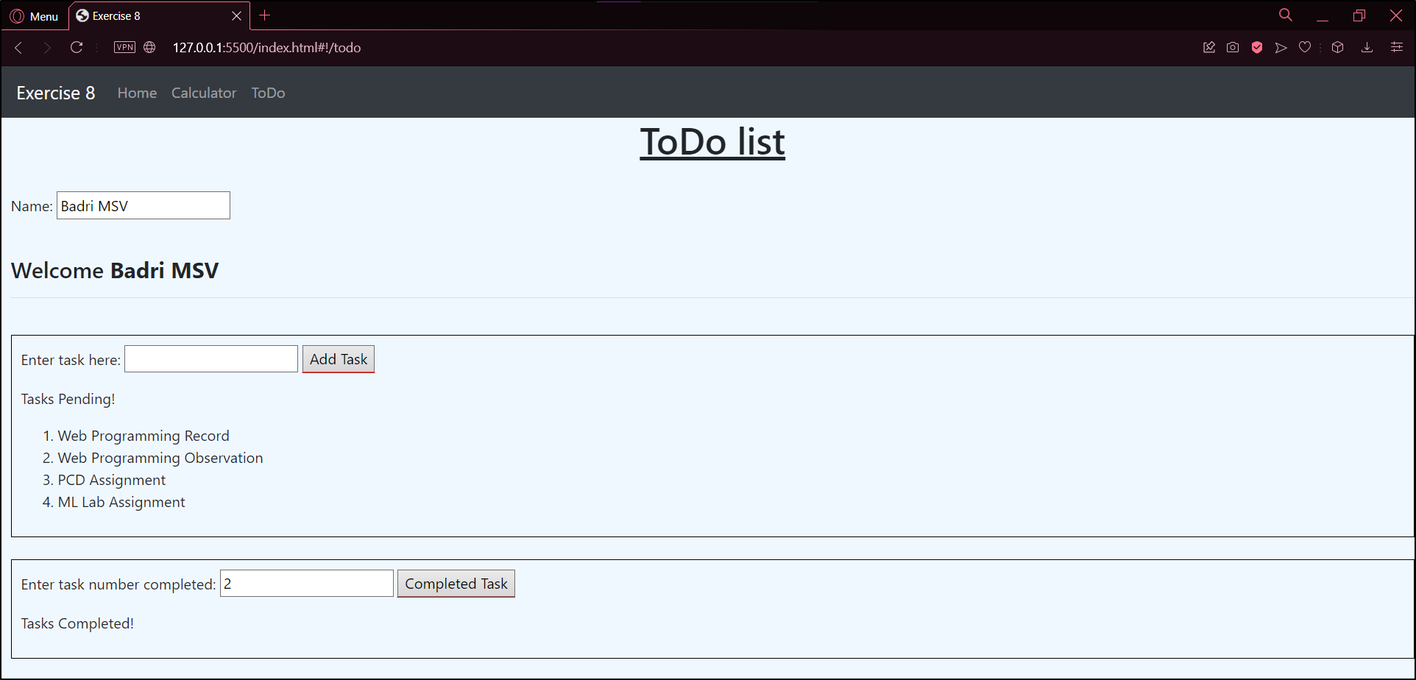

**Result:**

Thus, Navigation Menu was created using the ng-route feature of AngularJS.